# INTRODUCTION

A new generation born between year 1990 - 2010 are know as Generation-Z. We have heard words like “lit”, “bruh” and more from the mouth of the Gen-Z’s.

Whereas, the working generation refers to cohort of generation working in industry it includes

##### Generation X ( Born between 60s - 80s )

##### Generation Y ( Born between 80s - 90s ) also known as Millennial's

##### Generation Z ( Born between 90s - early 2010s )

##### Generation Alpha ( Born after 2010s )

# What is Happening around the world?

As we take reference of career aspiration of Gen-Z then it will be easy to say that in today’s world many challenges are faced by both employers and Gen-Z individuals are

##### Decline of the Planned Career

Planning a formal career path at one company is not what motivates this generation, they are less driven by the promise of stability then their predecessors, who grew up during the financial crisis Fig

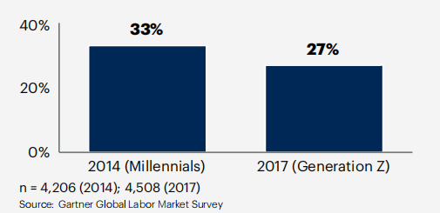

“Students get their first promotion and then their second and third promotions seems far away so they jump to a new company… after around two years, they have to go somewhere else to get to next step in their career”.

# ****When is this happening?****

This is started after the Covid 19 Pandemic. Pandemic has completely changed the mindset of Gen-Z and make them more focused on their work-life balance and their way of living.They prefer independence but not isolation,Gen Z places a high value on flexibility and work-life balance.

**“The COVID-19 pandemic has radically altered the attitudes and career aspirations of Gen Z. This change will come to define the world of higher education and work. It is absolutely critical that governments, universities and the industry are primed for this shift among young people to support a whole generation that is eager to learn and work differently,” said Olivia Streatfeild, CEO Of INTO University Partnerships.**

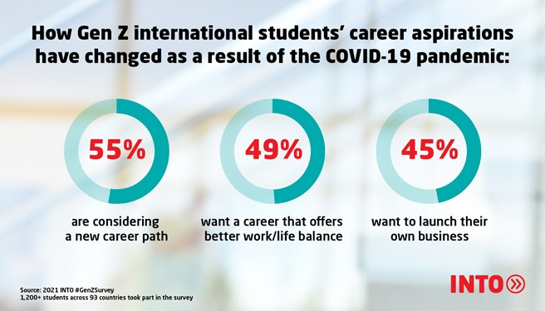

Stability emerges as a pivotal consideration for Gen Z when shaping their career paths. Respondents emphasized the importance of establishing a solid foundation for their professional journeys right from the outset. The aftermath of the COVID-19 pandemic has seemingly intensified their desire for stability in the workplace.

# Why is that a problem?

##### Economic Uncertainty:

##### Even without the pandemic, economic fluctuations can create instability in the job market, making it difficult for Gen Z to find secure and well-paying jobs.

##### High Expectations:

Gen Z often has high expectations for their careers, seeking meaningful work, rapid advancement, and a good work-life balance. These expectations can sometimes lead to dissatisfaction if not met.

##### Environmental Concerns:

Gen Z is highly aware of environmental issues and often seeks employers who are committed to sustainability. Finding such employers can sometimes limit their job options.

##### Increased Competition:

With more experienced candidates vying for entry-level positions, Gen Z may find it harder to secure jobs, leading to frustration and delayed career starts.

# ****who are affected?****

Businesses: Companies are profoundly impacted by the choices Gen-Z makes regarding their careers. Misinterpreting these aspirations can lead to challenges in talent acquisition, retention, and workforce diversity.

Educational Institutions: Schools and universities play a vital role in shaping Gen-Z’s perceptions of career opportunities. Understanding their aspirations can help educational institutions better align their curricula and career counseling services.

Parents and Guardians: Gen-Z individuals often seek guidance from their parents and guardians when making career decisions. Understanding their aspirations can aid parents in providing the right support and advice.

# Where Is This Happening?

This phenomenon is not confined to any single location; it is occurring wherever Gen Z individuals are actively building their careers. The effects are especially evident in various workplaces, ranging from established corporations to cutting-edge startups.

Gen-Z’s global outlook influences their career aspirations, making international collaboration and cultural diversity key considerations.

## How can employers attract and retain Gen Z talent?

Employers can create a workplace that not only attracts Gen Z talent but also retains them, fostering a loyal and motivated workforce.

**They should plan a new model for talent Management it could fundamentally change the view of employee cycle from traditional “attract”, “develop” and “retain” model**

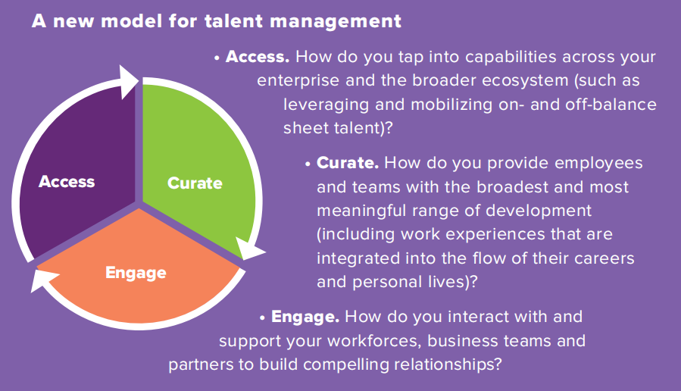

Recognition and Feedback: Implementing regular feedback and recognition programs to acknowledge achievements and provide constructive guidance

Positive Work Culture: Creating an inclusive, diverse, and supportive environment where employees feel valued and respected.

Growth Opportunities: Providing continuous learning and professional development programs to help employees advance in their careers.

# Conclusion

In Conclusion, Gen Z values work-life balance, meaningful work, tech-savvy environments, continuous learning, diversity, and has a strong entrepreneurial spirit. They are shaping the future of work with their unique perspectives and values.Employers will need to understand the behaviour of this generation. It’s important to Gen Z to work at organizations whose values align with their own.